﻿E4.1 Write a query to display all Theme Parks except those in the UK.

* Ans:
* 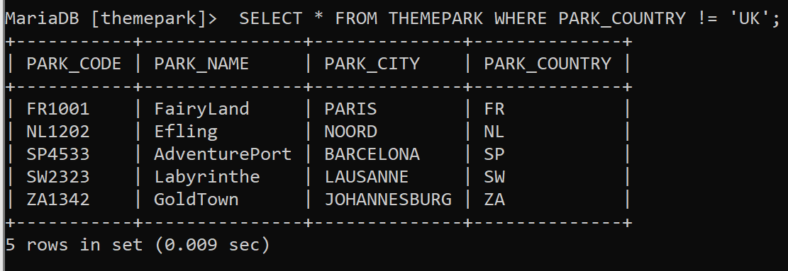

E4.2 Write a query to display all the sales that occurred on the 18th May 2007.

* 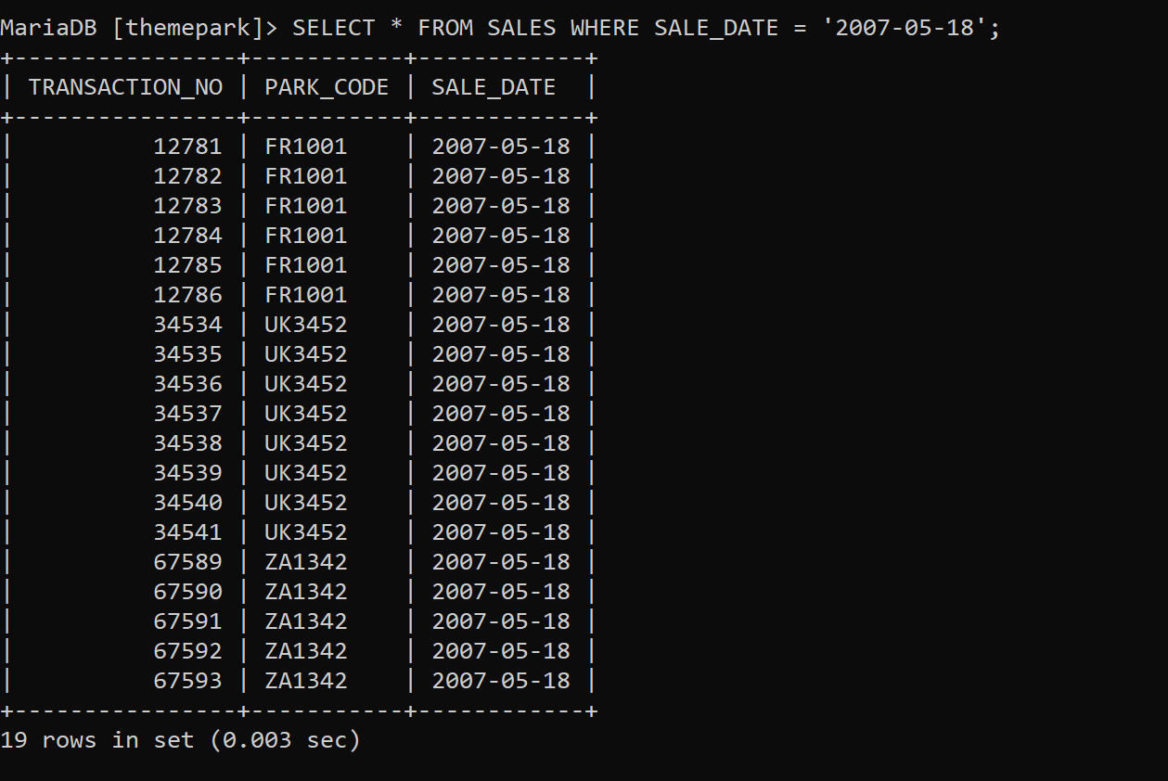

E4.3 Write a query to display the ticket prices between €20 AND €30.

* 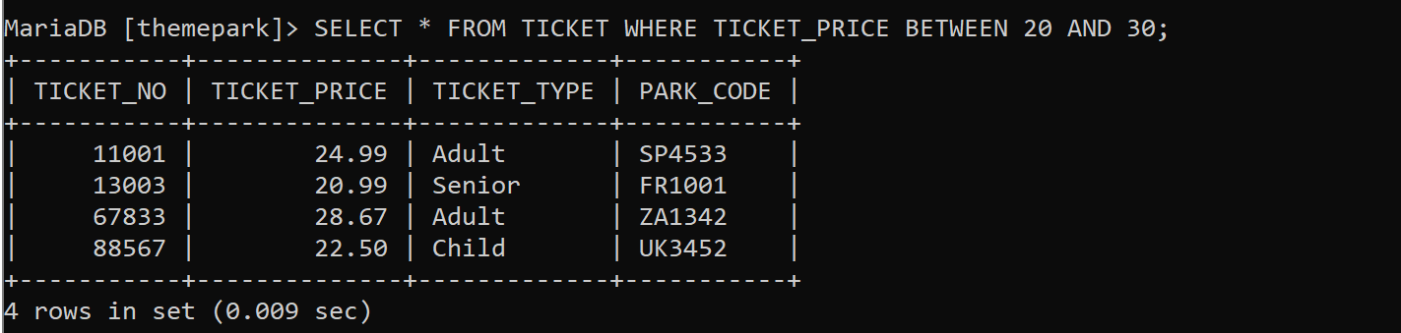

E4.4 Display all attractions that have a capacity of more than 60 at the Theme Park

FR1001.

* 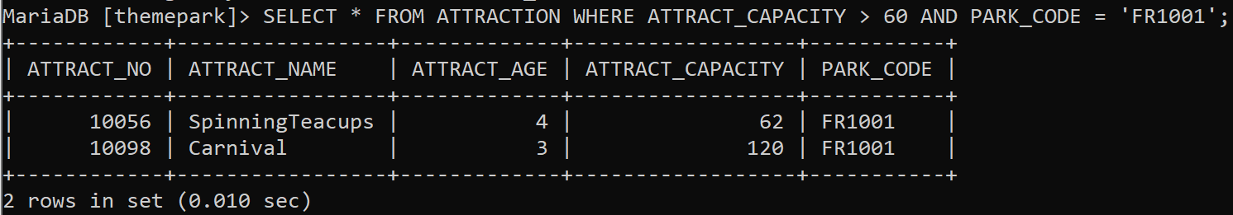

E4.5 Write a query to display the hourly rate for each attraction where an employee

had worked, along with the hourly rate increased by 20%. Your query should only ﻿display the ATTRACT_NO, HOUR_RATE and the HOUR_RATE with the 20% increase.

* 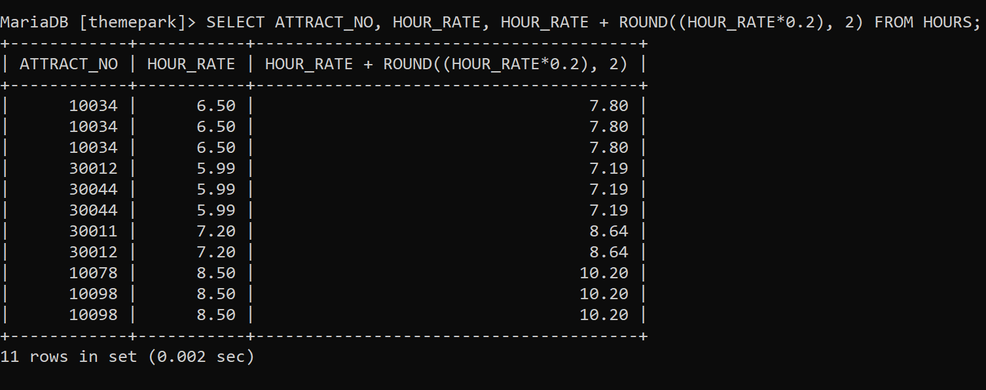

﻿E5.1 Write a query to display all unique employees that exist in the HOURS table;

* 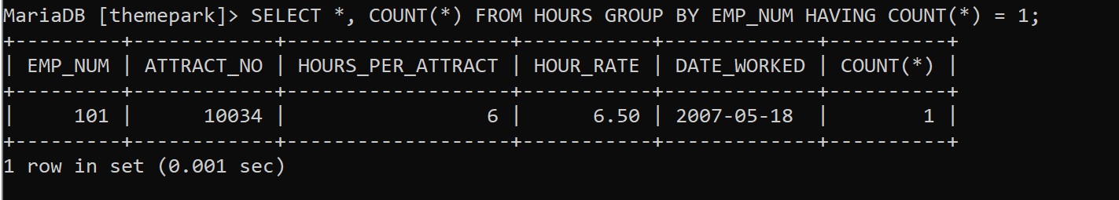

E5.2 Display the employee numbers of all employees and the total number of hours they

have worked. 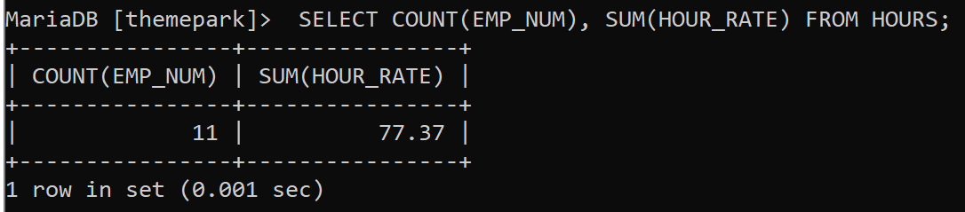

E5.3. Show the attraction number and the minimum and maximum hourly rate for each

attraction.

* 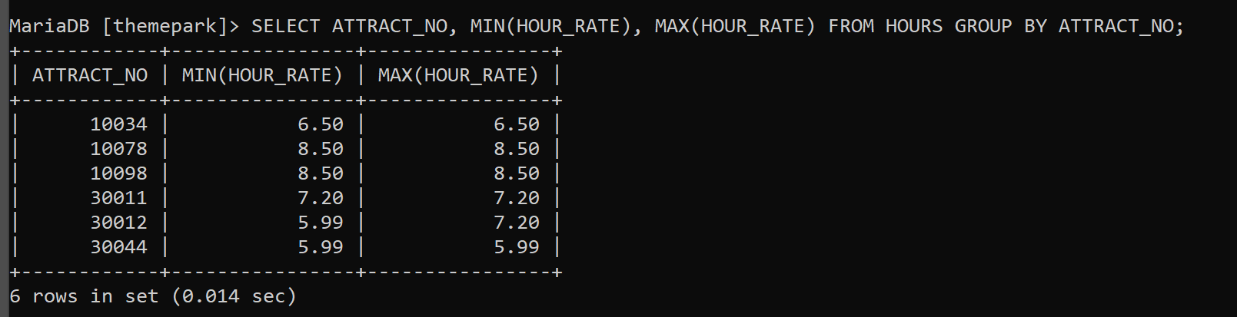

E5.4 Write a query to show the transaction numbers and line prices (in the SALES_LINE

table) that are greater than €50.

* 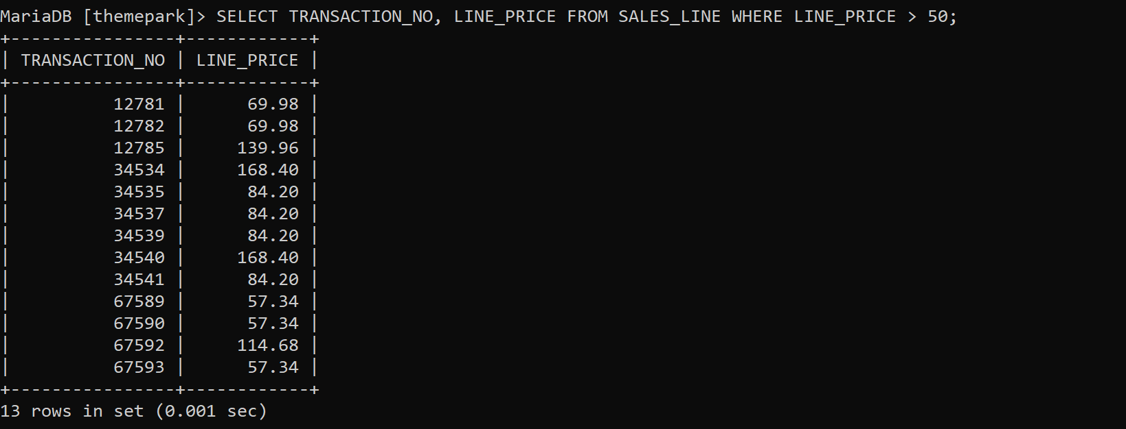

E5.5 Display all information from the SALES table in descending order of the sale date

* 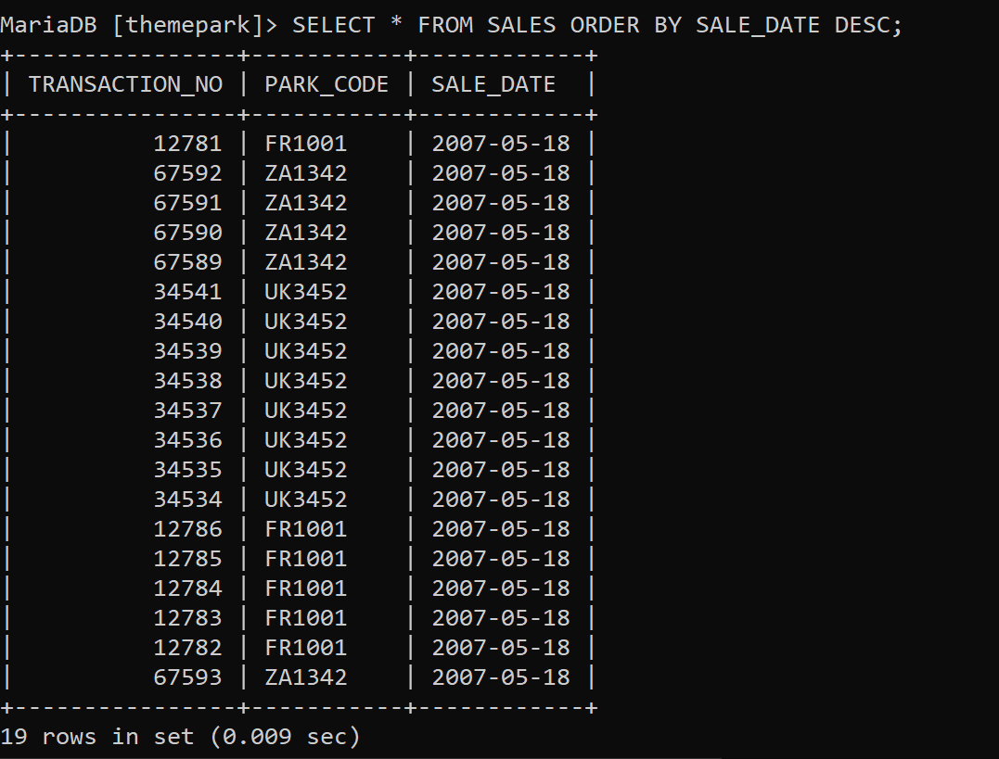

﻿E6.1 Use the cross join to display all rows in the EMPLOYEE and HOURS tables. How

many rows were returned?

* 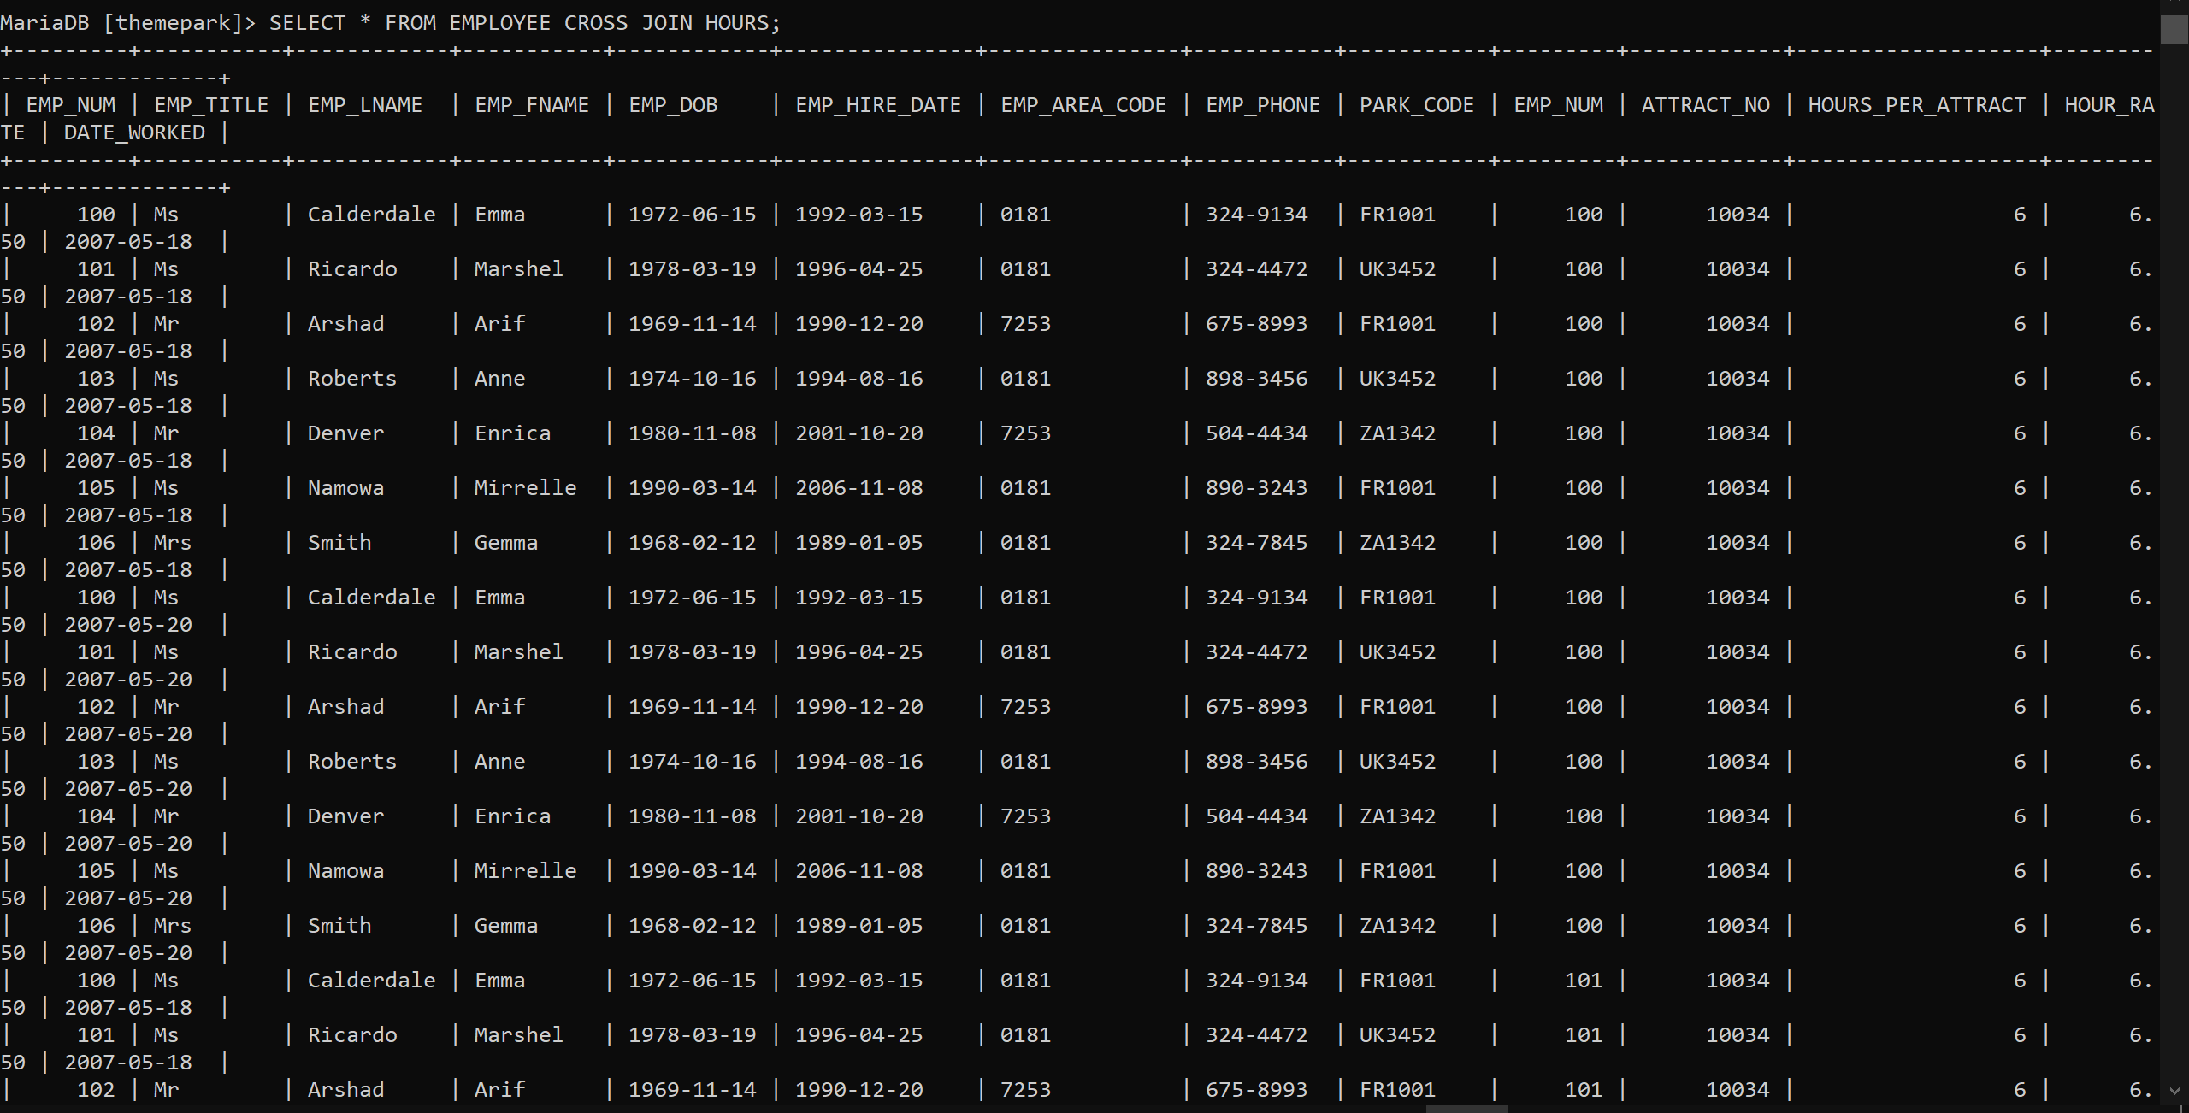

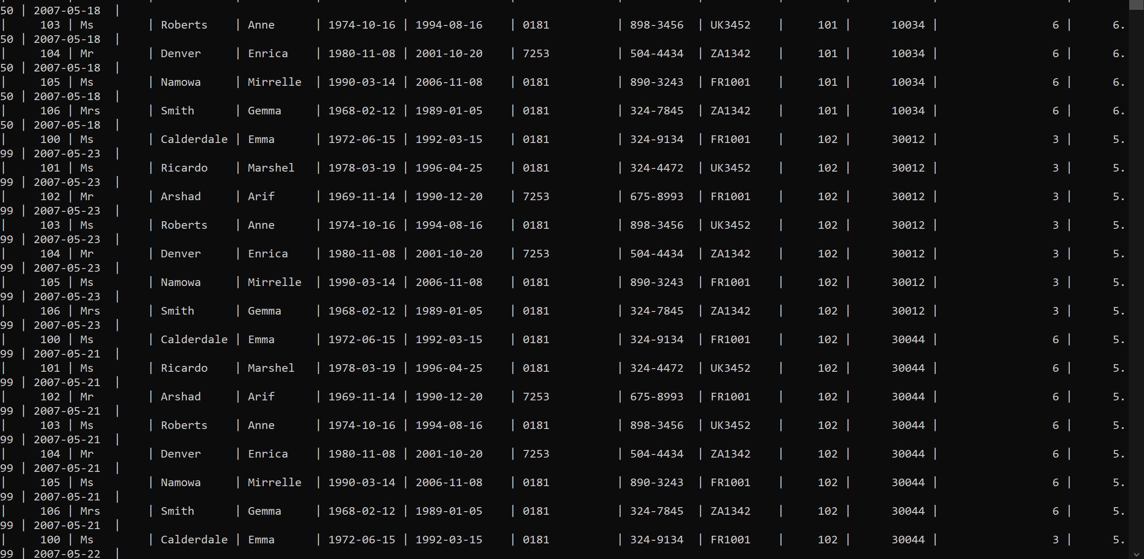

* 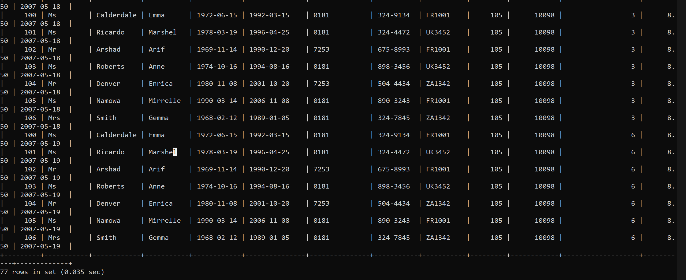

E6.2 Write a query to display the attraction number, employee first and last names and

the date they worked on the attraction. Order the results by the date worked.

* 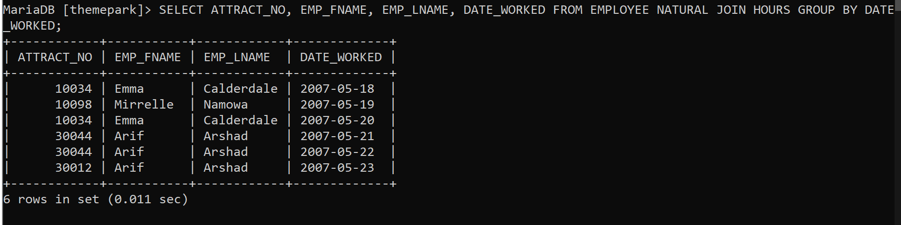

E6.3 Display the park names and total sales for Theme Parks who are located in the

country ‘UK’ or ‘FR’.

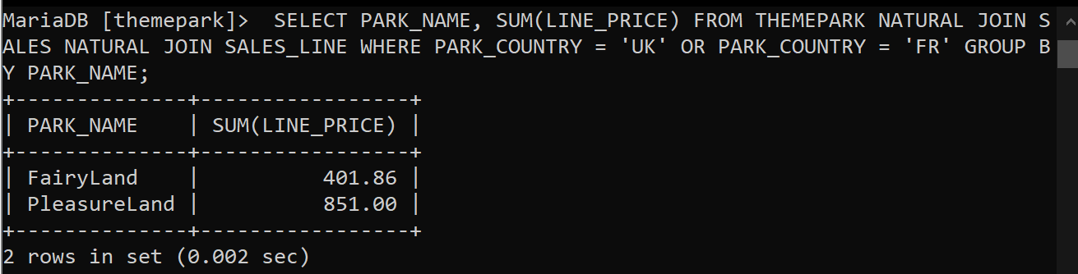

E6.4 Write a query to display the names of attractions that currently have not had any

employees working on them.

* 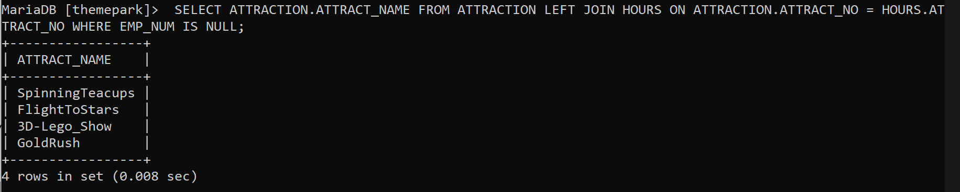

E6.5 List the sale date, line quantity and line price of all transactions on the 18th May

2007. (Hint: Remember the format of MySQL dates is ‘2007-05-18’).

* 